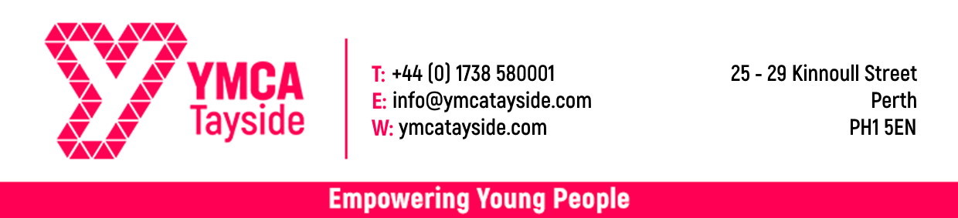
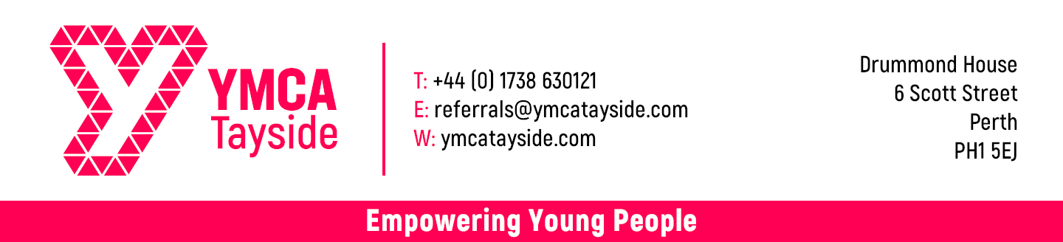

YMCA Referral Form
Is this referral for specific YMCA project? |  |  |  |  |  | Yes / No
If ‘Yes’ please specify which project it is for
Referrer / Referral Agency Details
Full Name
Tel |  |  |  |  |  |  | Agency Name
Mobile |  |  |  |  |  |  | Address
Email
Relationship to young person |  |  |  |  |  |  |  |  |  |  | Post Code
Key Contact Details (If different to referrer)

Young Person’s Details
Full Name |  |  |  |  |  |  |  |  | Age |  |  |  | D.O.B
Address |  |  |  |  |  |  | Contact Num.
 |  |  |  |  |  |  | Alt Contact
 |  |  |  |  |  |  | Email
Post Code |  |  |  |  |  |  | NI Number
Gender |  |  |  |  | Last Educational Establishment
Current Economic Status (please mark ‘X’ on all that apply)
Unemployed (claiming benefits) |  |  |  | Unemployed (no benefits) |  |  |  |  |  |  |  | Employed
In Education |  |  |  | In Further Education |  |  |  |  |  |  |  | In Training / Volunteering
Any other information relating to current economic status?

Personal Circumstances (please mark ‘X’ on all that apply)
Long-term unemployed |  |  | Disability |  |  | Mental Health Issue
Homeless |  |  | Long term illness |  |  | Dyslexia
Learning Difficulties |  |  | Anxiety Issues |  |  | ADD / ADHD
Asylum Seeker / Refugee |  |  | Carer / Caring responsibilities |  |  | Care Experienced
Ethnic Minority |  |  | English as a 2nd language |  |  | Gypsy Traveller
NEET |  |  | At risk of becoming NEET |  |  | Criminal Convictions
No Work Experience |  |  | Low Educational Attainment |  |  | Low Income Employed
Substance Misuse |  |  | Financial Difficulties |  |  | Rurally Isolated
Socially Isolated |  |  | Other (please specify)
Please briefly describe the young person’s internet connectivity situation. (Do they have internet access? Via what means, etc…)
Reason for referral (please give us some background information about the young person. The more detail the better)
Declaration
By signing below you are confirming that (1) The information above is correct and up to date to the best of your knowledge. (2) You have the consent of the person in question to pass over the information that you have provided and the person is aware you are doing so and that we will follow this referral up with an offer of support. (3) In the event the person is not able to consent for themselves, you have the consent of a parent / carer / guardian who is legally allowed to give consent on their behalf.
Print Name
Signature |  |  |  |  | Date

For official use (To be filled in by YMCA worker)
Key worker allocated |  |  |  |  |  |  | Date of 1st Meeting
Project worker assessment (please give your initial assessment of the kind of support this young person will require and any issues we should be aware of)
Intervention identified (Please identify the kind of work the young person will be a part of: groups/courses/1:1/etc) |  |  |  |  |  | Times / Frequency |  |  |  | Funding stream allocation
Eg: Employability group work |  |  |  |  |  | Every Wednesday 2 – 4pm |  |  |  | ESF Y Futures
Key areas for development (Please mark ‘X’ on all that apply)
Confidence |  |  | Communication |  |  |  |  |  | Qualifications
Social Skills |  |  | Support Networks |  |  |  |  |  | Training
Core Skills |  |  | Motivation |  |  |  |  |  | Time Keeping
Literacy / Numeracy |  |  | Employability |  |  |  |  |  | Developing a positive routine
Other (please specify)
When will work commence |  |  |  | Date: |  |  |  |  | Time:

